| **S No.** | **Arduino** | **Raspberry Pi** |
| --- | --- | --- |
| 1. | In the year 2005, the classrooms of the Interactive Design Institute in Ivrea, Italy, first introduced the Arduino board. | In the year 2012, Eben Upton first introduced the Raspberry Pi device in February. |
| 2. | Control unit of the Arduino is from the Atmega family. | The control unit of Raspberry Pi is from the ARM family. |
| 3. | Arduino is based on a microcontroller. | While Raspberry Pi is based on a microprocessor. |
| 4. | It is designed to control the electrical components connected to the circuit board in a system. | While Raspberry Pi computes data and produces valuable outputs, and controls components in a system based on the outcome of its computation. |
| 5. | Arduino boards have a simple hardware and software structure. | While Raspberry Pi boards have a complex architecture of hardware and software. |
| 6. | CPU architecture: 8 bit. | CPU architecture: 64 bit. |
| 7. | It uses very little RAM, 2 kB. | While Raspberry Pi requires more RAM, 1 GB. |
| 8. | It clocks a processing speed of 16 MHz. | While Raspberry Pi clocks a processing speed of 1.4 GHz. |
| 9. | It is cheaper in cost. | While Raspberry Pi is expensive. |
| 10. | It has a higher I/O current drive strength. | While Raspberry Pi has a lower I/O current drive strength. |
| 11. | It consumes about 200 MW of power. | While it consumes about 700 MW of power. |
| 12. | Its logic level is 5V. | Its logic level is 3V. |
| 13. | It does not have internet support. | It has inbuilt Ethernet port and WiFi support. |
| 14. | It has higher current drive strength. | It has lower current drive strength. |
| 15. | Some of the applications of Arduino are traffic light countdown timer , Weighing machines , etc. | Some of the applications of Raspberry Pi are Stop motion cameras , Robot Controllers , Game Servers. |
| 16. | Operating systems are required in Arduino. | Operating System is required in Raspberry Pi. |
| 17. | Two tiny cores Arduino with 32 Mhz | Single core and 700 MHz |

**Ardunio uno**

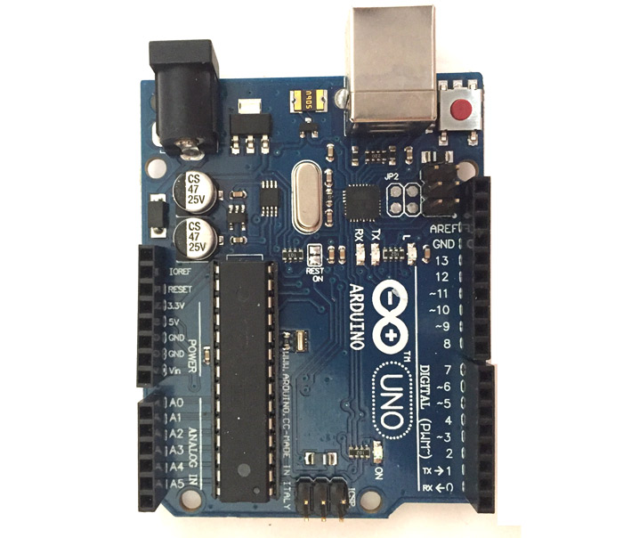

**Arduino Uno** is a popular microcontroller development board based on 8-bit [ATmega328P](https://components101.com/microcontrollers/atmega328p-pinout-features-datasheet) microcontroller. Along with ATmega328P MCU IC, it consists other components such as crystal oscillator, serial communication, voltage regulator, etc. to support the microcontroller.

**Arduino Uno Pin-out Configuration**

|  |  |  |
| --- | --- | --- |
| **Pin Category** | **Pin Name** | **Details** |
| Power | Vin, 3.3V, 5V, GND | Vin: Input voltage to Arduino when using an external power source.  5V: Regulated power supply used to power microcontroller and other components on the board.  3.3V: 3.3V supply generated by on-board voltage regulator. Maximum current draw is 50mA.  GND: ground pins. |
| Reset | Reset | Resets the microcontroller. |
| **Analog Pins** | **A0 – A5** | **Used to provide analog input in the range of 0-5V** |
| **Input/output Pins** | **Digital Pins 0 - 13** | **Can be used as input or output pins.** |
| Serial | 0(Rx), 1(Tx) | Used to receive and transmit TTL serial data. |
| External Interrupts | 2, 3 | To trigger an interrupt. |
| PWM | 3, 5, 6, 9, 11 | Provides 8-bit PWM output. |
| SPI | 10 (SS), 11 (MOSI), 12 (MISO) and 13 (SCK) | Used for SPI communication. |
| Inbuilt LED | 13 | To turn on the inbuilt LED. |
| TWI | A4 (SDA), A5 (SCA) | Used for TWI communication. |
| AREF | AREF | To provide reference voltage for input voltage. |

# **Raspberry Pi Pin out Diagram**

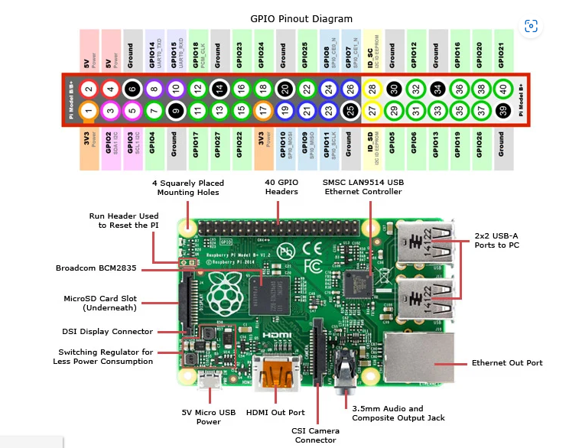

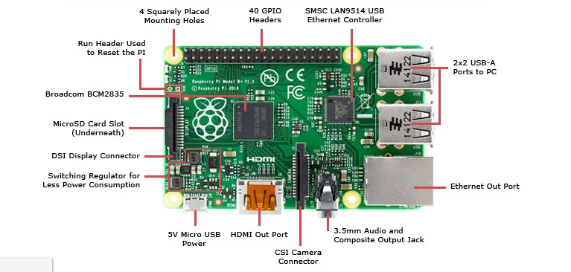

The Raspberry Pi is a credit card sized single-board computer with an open-source platform that has a thriving community of its own, similar to that of the **[Arduino](https://www.jameco.com/z/A000066-Arduino-Arduino-Uno-R3-DIP-Edition-Revision-3-Genuine-Microcontroller_2151486.html)**. It can be used in various types of projects from beginners learning how to code to hobbyists designing home automation systems.

There are a few versions of the Raspberry Pi, but the latest version, has improved upon its predecessor in terms of both form and functionality. The Raspberry Pi Model B features:  
  
• More GPIO  
• More USB  
• Micro SD  
• Lower power consumption  
• Better audio  
• Neater form factor

This higher-spec variant increases the Raspberry pi GPIO pin count from 26 to 40 pins. There are now four USB 2.0 ports compared to two on the Model B. The SD card slot has been replaced with a more modern push-push type micro SD slot. It consumes slightly less power, provides better audio quality and has a cleaner form factor.  
  
To get started you need a Raspberry Pi 3 Model B, a [5V USB power supply](https://www.jameco.com/z/313990002-Seeed-Studios-5-Volt-2-1-Amp-10-Watt-USB-Wall-Power-Supply_2217617.html) of at least 2 amps with a [micro USB cable](https://www.jameco.com/z/10U2-20126-03-Jameco-Valuepro-3-Foot-micro-USB-Data-Sync-and-Power-Charge-Cable_2135064.html), any standard USB keyboard and mouse, an [HDMI cable](https://www.jameco.com/z/10HM-01128V4-02-Jameco-Valuepro-HDMI-Cable-Male-to-Male-2-Meters_1944151.html) and monitor/TV for display, and a micro SD card with the operating system pre-installed.